**Module (JQueryBasic,Effects& Advanced) – 5**

1. **What is jQuery?**

**Ans :** [jQuery is a**small, light-weight and fast JavaScript library**](https://www.bing.com/ck/a?!&&p=a051a042d482b82dJmltdHM9MTcxOTI3MzYwMCZpZ3VpZD0yZWVkZTM3OC01MjAwLTZkNTYtMDQzYy1mMDE1NTM5YjZjZjUmaW5zaWQ9NTkxMg&ptn=3&ver=2&hsh=3&fclid=2eede378-5200-6d56-043c-f015539b6cf5&psq=%e2%80%a2+What+is+jQuery%3f++&u=a1aHR0cHM6Ly93d3cuamF2YXRwb2ludC5jb20vd2hhdC1pcy1qcXVlcnk&ntb=1)

1. **How to Apply CSS Using JQuery, How to Add Class and Remove Class in Jquery ,JQuery Animation?**

**Ans :**To apply CSS using jQuery

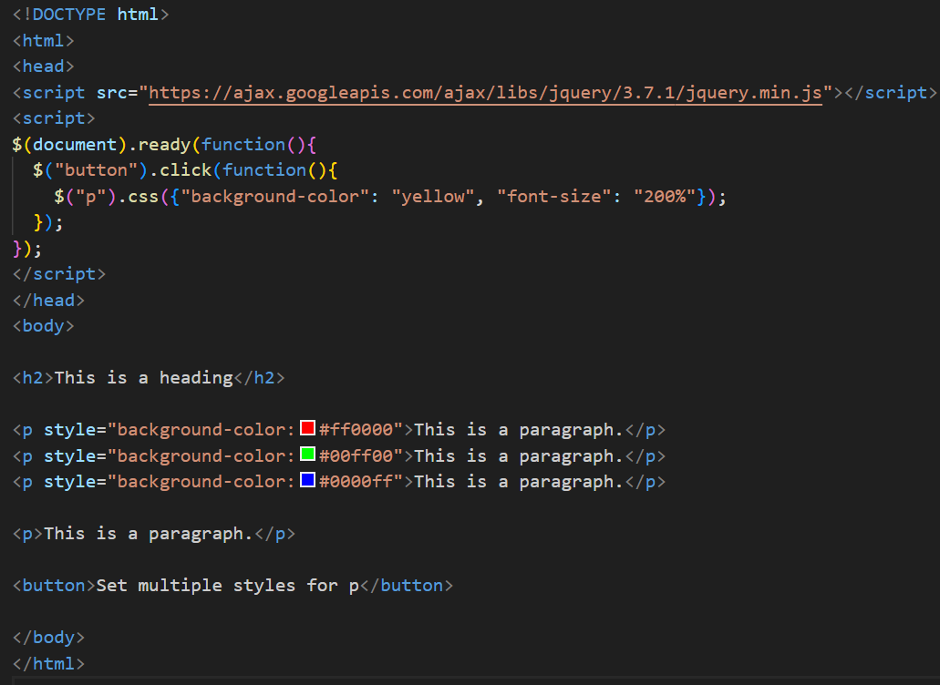

**Add Class**

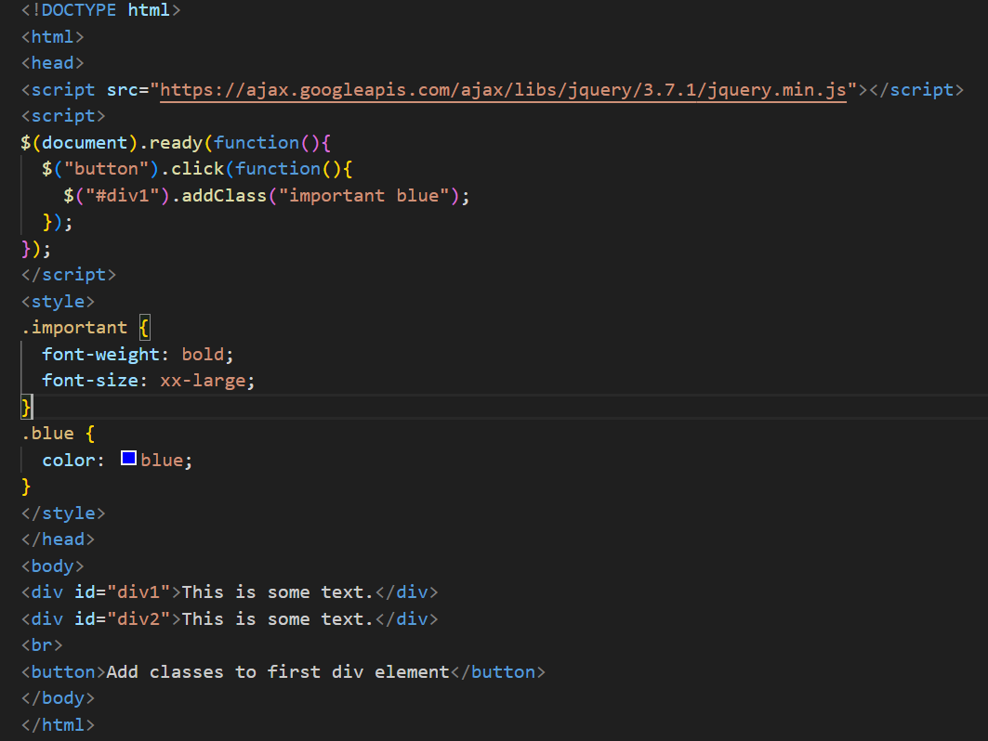

**Remove Class**

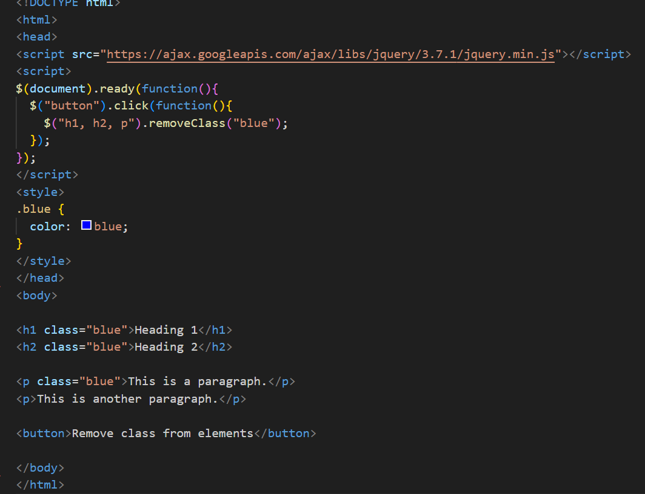

**JQuery Animation**

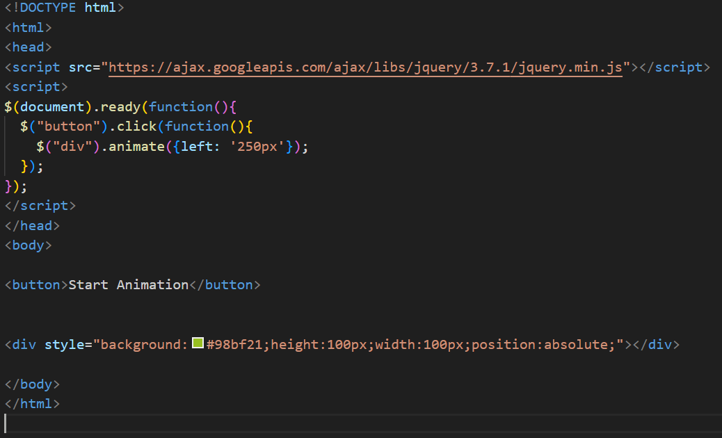

**3.How to create slider with animation?**

Ans :To create a slider with animation using jQuery:

